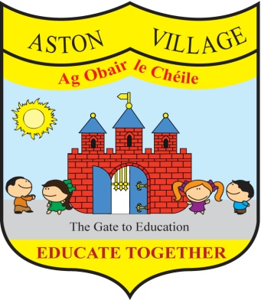
AGREED STATEMENT FROM THE BOARD OF MANAGEMENT
October 2019
New Staff - The Board extends a warm welcome to new staff who have joined us this year, teachers Tasha and Kate and SNAs Niamh and Dragan. The Board wishes staff and pupils every success for the 2019-2020 school year and looks forward to supporting your teaching and learning.
Clever Clogs - The Board welcomes the full service now on offer by Clever Clogs who provide pre-school and after-school care for children in our school community. We wish our friends in Clever Clogs continued success and we also welcome back all the other users of our school buildings who provide a broad range of valuable after-school activities for our pupils.
Student Council - The Board supports children taking leadership roles in our school and congratulates pupils elected by their peers to the Student Council for 2019-20. We look forward to working with you and welcome your help to make our school an excellent place to learn.
Child Safeguarding - The Board has completed our annual review of our Child Safeguarding Statement which is available on our school website, at reception and in all classrooms. This statement provides an overview of the measures in place in our school to ensure that our pupils are protected from harm. We thank you for your cooperation with these measures to ensure children's safety. We advise that anyone with concerns about child safety in our school should contact Principal Dermot who is the designated liaison person or Deputy Principal Pauline who is the deputy DLP.
Anti-Bullying Policy & Procedures - The Board has also conducted an annual review of our Anti-Bullying policy and procedures. We aim to ensure that all children feel safe and happy in our school. Led by Anti-Bullying Coordinator Des, teachers use anti-bullying surveys and lessons to help prevent bullying and children are encouraged to report any concerns about bullying to a staff member. Please see our Anti-Bullying Policy on our school website, where you can also complete anti-bullying survey or make a report.

