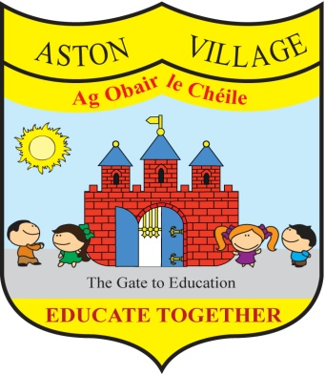
AGREED STATEMENT FROM THE BOARD OF MANAGEMENT
May 2019

CEO Retirement - The Board notes the announcement by Paul Rowe, CEO of Educate Together, that he is retiring. The Board acknowledges his significant contribution to education in Ireland and wishes him well in his retirement.
School Management Team - The Board congratulates teacher Naomi Reid on her recent appointment to the post of Assistant Principal 2.
Digital Learning Plan - The Board welcomes the development of a Digital Learning Plan for the school and encourages parents to access it on the school website. This is an initiative which aims to help teachers effectively embed digital technologies into their practice and promote active learner participation and engagement using ICT.
Book Fair 2019 - The Board thanks parents and children for generously supporting our Book Fair which was very well-supported by families yielding a total of over €3000 worth of new books to augment our school and class libraries.
Big Year in Big School - The Board welcomes the school's selection to feature in a new BAI-funded TV series entitled Big Year in Big School which will follow the lives of our new Junior Infants class during their first year at school.

