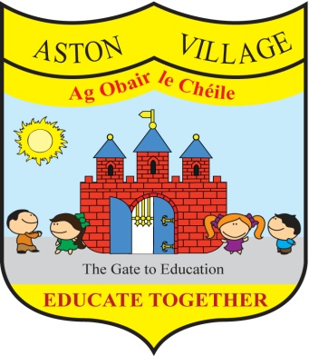
AGREED STATEMENT FROM THE BOARD OF MANAGEMENT
June 2019
Attendance - The Board notes that average monthly attendance this school year has been running at 93% which is a 2% increase since 2015 and is in line with our attendance strategy (2018). The Board asks parents to continue to support the school in our endeavour to improve and maintain a high standard of attendance and punctuality.
Newtown Blues - The Board extends thanks to our local GAA club Newtown Blues for generously hosting our school sports day and congratulates pupils and staff for its great success in a spirit of fun and team-work.
Assessment - The Board welcomes the results of annual standard testing in English and Maths and notes that the school is performing favourably by comparison with national norms. Reports will soon issue to parents and parents are encouraged to access these using the Aladdin Connect app.
STEM Fair - The Board thanks parents who attended our first STEM fair in large numbers and commends pupils and staff for their contributions to the fair with demonstrations, presentations, discoveries and projects.
Enrolment - The Board is reviewing the school's admissions policy in light of the planned commencement of the Education (Admissions to Schools) Act 2018 which will preclude a first come first served policy. The school will not accept pre-enrolment application forms for September 2024. A new admission policy will be approved with an annual admissions process for this intake group.

