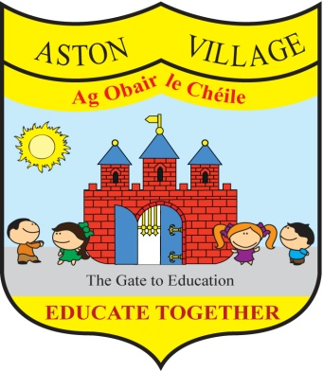
AGREED STATEMENT FROM THE BOARD OF MANAGEMENT
SEPTEMBER 2018
The Board extends good wishes to the school community as we begin a new school year.
The Board notifies the school community that the school child safeguarding statement and anti-bullying policy are under review and welcomes input from all stakeholders.
The Board welcomes the results of standard testing of pupils in English and Maths conducted at the end of the summer term and notes that while different tests were used this year and some scores were lower than anticipated, the school compares favourably with national norms. The Board congratulates staff and pupils on their achievements.
The Board notes that anti-bullying class surveys have taken place and encourages all members of the school community to continue to work together to prevent bullying.
The Board welcomes the school's re-engagement with the process of school self evaluation to bring about incremental improvements in teaching and learning and encourages parents to respond to school surveys from time to time in support of their children's learning.

