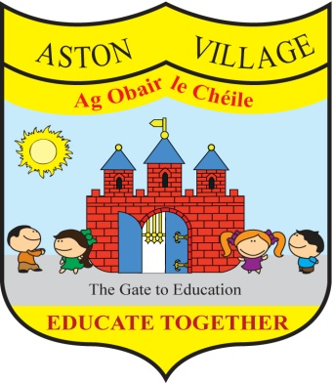
AGREED STATEMENT FROM THE BOARD OF MANAGEMENT
NOVEMBER 2017
The Board welcomes new members Joshua Jenkinson, ET Nominee and Sandra Wogan, Teachers' Nominee to the Board and extends good wishes to the school community as we begin a new school year.
The Board notes that the school's Homework Policy is under review and welcomes input from all stakeholders to ensure that homework supports teaching and learning in a positive way.
The Board welcomes the results of standard testing of pupils in English and Maths conducted at the end of the summer term and notes that the school compares very favourably with national norms. The Board congratulates staff and pupils on year-on-year improvement in standards.
The Board notes that anti-bullying class surveys will soon take place and encourages all members of the school community to continue to work together to prevent bullying.

