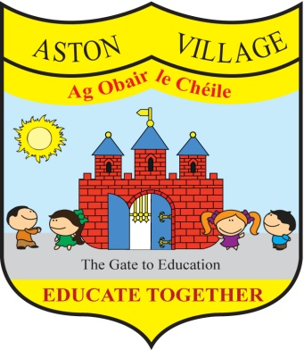
AGREED STATEMENT FROM THE BOARD OF MANAGEMENT
MAY 2017
The Board welcomes the commencement of works to improve the play area for Coiscéim and renews its' thanks for the huge voluntary fundraising work undertaken by parents, staff and friends of the school.
The Board extends thanks to school pupils, staff and parents who are helping to promote environmental awareness and care and congratulates the school community on our recent award by An Taisce of a Green Flag for water conservation.
The Board notes that anti-bullying class surveys took place after mid-term break and encourages all members of the school community to continue to work together to prevent bullying.
The Board encourages everyone to support our Skipathon fund-raiser for Educate Together to support our growing network of schools and to help make equality-based education available to all children in Ireland.

