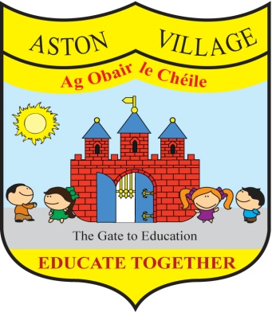
AGREED STATEMENT FROM THE BOARD OF MANAGEMENT
MARCH 2018
The Board welcomes the establishment of a Hellenic School in Aston Village to serve the needs of Greek members of our school and of those in the wider local community.
The Board urges drivers to take due care in the vicinity of the school to ensure the safety of children coming to and from school and reminds parents to use the turning circle in the school grounds or continue along Dunlin Street and around by Heron Street rather than doing u-turns which endanger pedestrians and other road users.
The Board thanks teaching staff for undertaking training as facilitators of the Rainbows Programme to support children coming to terms with loss due to bereavement and parental separation; for undertaking additional training in RSE; and for completing CPD in the teaching of science.
The Board is pleased to approve the school's new Statement of Strategy for School Attendance which is available on the school website.

