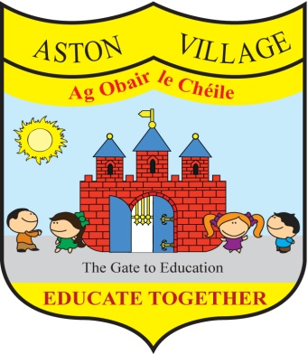
AGREED STATEMENT FROM THE BOARD OF MANAGEMENT
FEBRUARY 2017
The Board welcomes the erection of the school's new Polytunnel and acknowledges its generous funding by the school community. This resource will greatly enrich teaching and learning opportunities around promoting environmental awareness and care. Special thanks to teacher Brian for his commitment to leading this project and to staff and parent volunteers for getting involved.
The Board acknowledges the work of the Green Team and teacher Naomi who are successfully leading the school community in water conservation to achieve a fourth Green Flag.
The Board extends thanks to school staff who are volunteering for our Breakfast Club each morning. The Board welcomes this pilot scheme and notes the positive changes that it brings about for children who are availing of it.
The Board is pleased to have ratified a new policy on vetting which has been published on our school website. The school will use this policy as part of a wider process to ensure the protection and safety of all members of the school community.
The Board notes that anti-bullying class surveys will take place after mid-term break and encourages all members of the school community to work together to prevent bullying.

