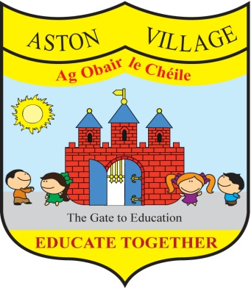
AGREED STATEMENT FROM THE BOARD OF MANAGEMENT
DECEMBER 2018
10th Anniversary celebrations - The Board welcomes plans to celebrate the school's 10th anniversary and encourages all members of the school community to support and participate in planned activities.
SSE surveys - Teachers have been looking at their practice in the teaching and learning of Gaeilge with the view to identifying strengths and areas for improvement. Parents and children will be surveyed early in the New Year and are encouraged to participate.
Road safety - the Board notes parental concerns about road safety in the vicinity of the school and has asked Louth County Council to improve road signage and markings on the approach to the school. Parents are reminded to drive and park with due care to reduce risk to children and other pedestrians.
Child Safeguarding - the Board has reviewed the school's child safeguarding statement and risk assessment and thanks everyone for their input on this. The child safeguarding statement and risk assessment are available on our school website www.astonvillageetns.com and on the welcome notice-board in the front lobby of the school.
Parent Teacher Meetings - the Board extends thanks to teachers and parents who were very flexible and accommodating in their joint efforts to ensure that all parents were met at recent parent-teacher meetings to review children's progress.
Sandra - The Board thanks Board member and teacher Sandra Wogan for all her hard work as teachers' nominee and wishes her all the best on her maternity leave. A new teachers' nominee will be elected by teachers in January 2019.

