Monthly Aistear Wishlist – November
On behalf of our Aistear teachers, Liz and Orla, thank you for all your donations to the Aistear Farm and Harvest theme in October. If you have any of the items listed below that are in very good condition (ie no broken or missing parts) they can be dropped to the office after midterm. We greatly appreciate your support!

Theme: Food and Clothing

Trolleys

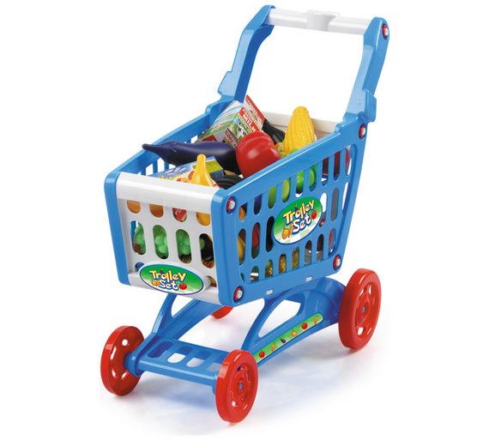

Clothes hangers/rails

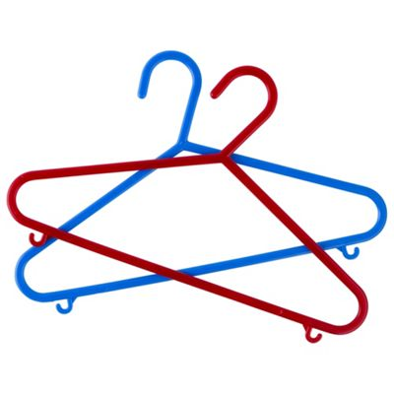

Dress up clothes

Shopping baskets

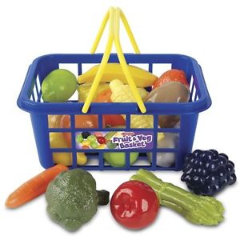

Tills/Cash registers
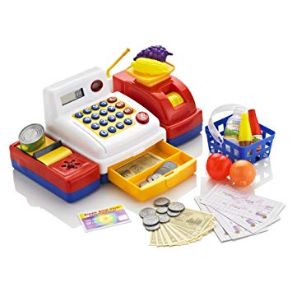
Toy miniatures for shop theme
