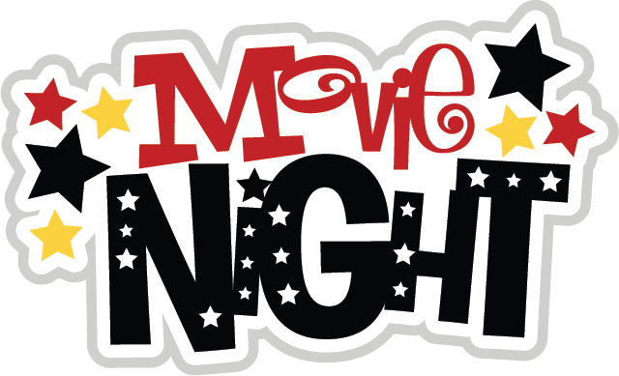
THURSDAY 26TH NOVEMBER 6PM – 7.45 PM
TICKETS €3 (to include popcorn, a treat and a drink)
WIN A MINION! Raffle tickets will be on sale on the night for 3 x Minion characters priced at €1 per strip or 3 strips for €2

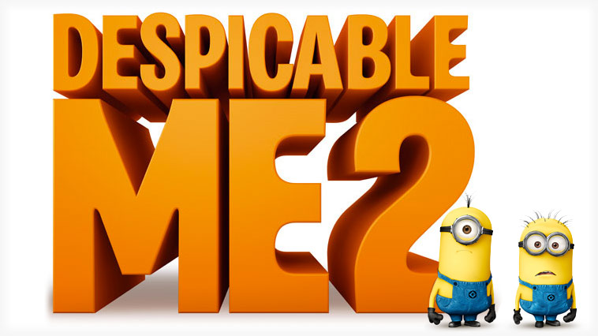
ALL PROCEEDS WILL GO TOWARDS FUNDING OUR NEW SCHOOL STAGE

