Aston Village E.T.N.S
Green Code

Green school energy submission
February 2015

Introduction
Everyone associated with Aston Village E.T.N.S was delighted when the school was awarded a Green Flag in May 2013. We were honoured to raise the flag on the new flag pole outside the front of the school for everyone to see. This was a most memorable occasion. Every day as we drive in to school we see the flag blowing in the wind and this reminds of the hard work and determination in our school and the things that we can achieve when we work together as a school community and a wider community in the area. It also reminds us of the importance of being aware and making others aware of the importance of environmental issues. The aims and objectives of the Green School campaign are now fully embedded in the daily life of Aston Village E.T.N.S. We now feel ready to apply for our Green Flag for Energy.

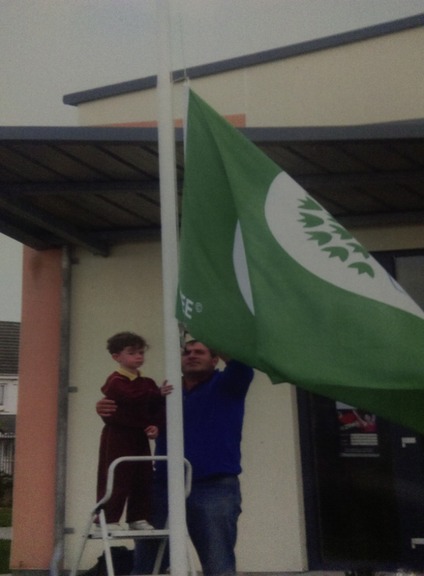

Memories of our first Green Flag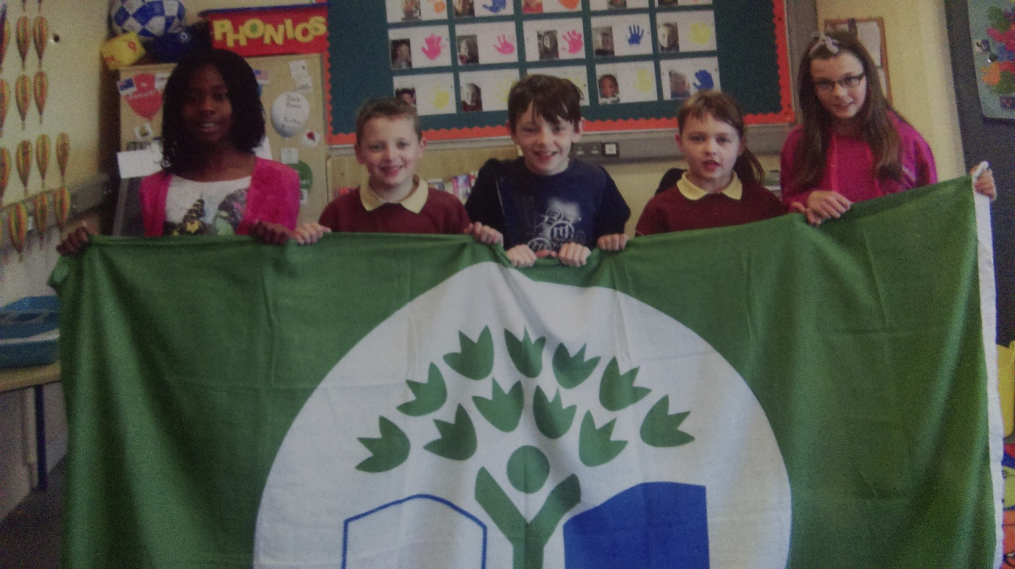
Bringing the flag back to our school
‘We were in the paper !”
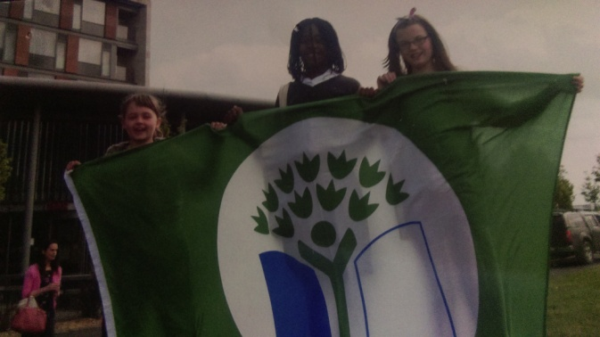
The day we got our flag.

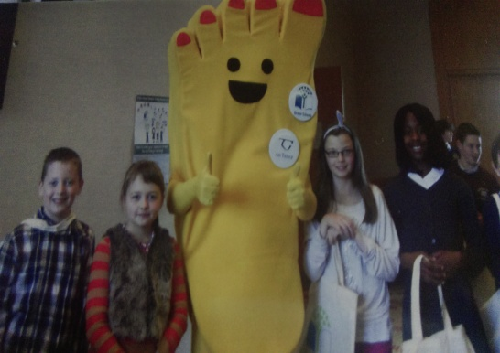
Look who we met!

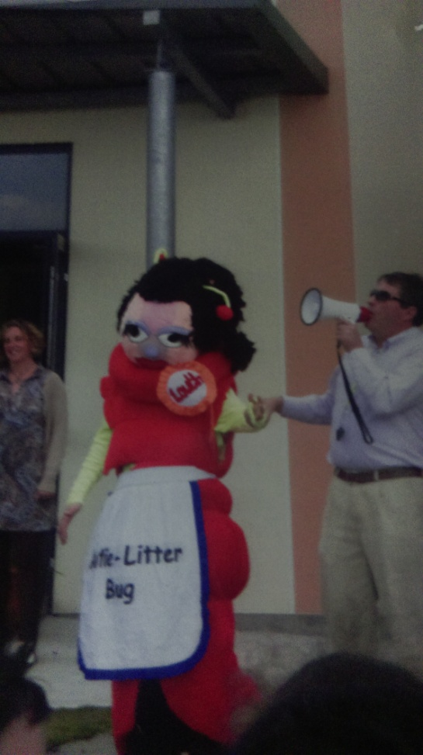
Auntie Litter Bug paid a special visit.

Step 1: Green School Committee
We changed our committee each year in order to give many children a chance to take part and to get as many ideas on board as possible. Each child who wanted to take part had to put together a presentation to present to their class and then we democratically voted for the two children from each class that we felt were going to work hard and try their best to promote an awareness in the school and Be Green !
Green School committee 2013/2014
This green school committee worked very hard to ensure that all our aims for the Litter and Waste management Flag were continued throughout the school. We made new posters and signs for all the bins and made sure that each class had a general waste bin, compost bin, paper bin and a bin for pencil sharpenings. We devised a new litter picking rota and also a compost bin rota. We then went on to get prepared for our Green Flag for Energy. Although the Green School committee would work hard to promote Green awareness in the school it was important to have the support of the whole school and the school and wider community. It was necessary for the whole school community to take part in various actions, competitions, trips and environmental education initiatives.
Green Team 2013/2014
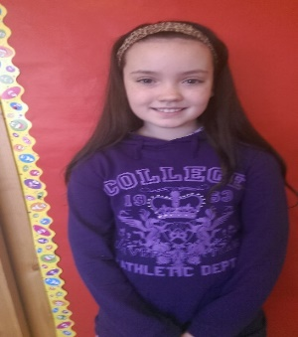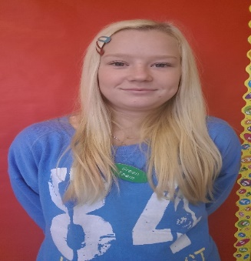
Aaron Katie Anna
David India Jason
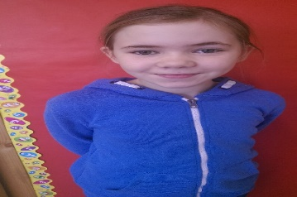
Nife Olayemi Philippa

Green school committee 2014/2015
Leylana | Jack | Nife
Aaron | Julia | Lota
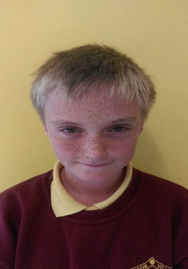 | 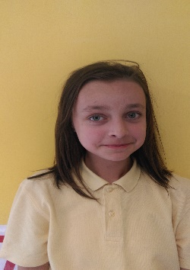
Rob | Donata | Ella

The Green school Committee comprises of:
Conor Brennan Chairman - Board of Management
John Kelleher Principal
Maria Harmon 3rd Class Teacher
Naomi Reade Junior Infants Class Teacher
Delyse O’Donovan Special Needs Assistant
Áine Walsh Tidy Towns representative
Frank School Caretaker
Michelle, Kim Cleaners
All students in Aston Village E.T.N.S
2013/2014 Committee: Aaron, Katie, Anna, David, India, Jason, Nife, Olayemi, Philippa.
2014/2015 Committee: Leylana, Jack, Madina, Aaron, Julia, Lota, Rob, Donata, Ella, Nife.

The committee meets at least once per month, but usually more regularly at times when there is a large project or action plan to organise. During meetings we discuss any new suggestions from members and evaluate any new tasks which have been undertaken. All new programmes including litter and waste management programmes and energy programmes are discussed in great detail at all meetings and progress is monitored and the Action Plan is monitored in great detail to ensure that we are on track. Minutes are taken and the jobs of the group members are discussed to ensure everyone understands what progress has to be made.

Step 2 Environmental Review
Litter & Waste

We revisited and re-examined our initial environmental review for our last Green flag. We were very happy with our efforts in our Anti-Litter ad waste reduction campaign. We will continue to use our litter rota (see appendix), our compost bin rota (see appendix) and also our lunch box scheme in order to reduce waste. The green school committee must also make sure that each classroom and office has the appropriate bins – general waste, compost, plastic and pencil sharpening and bin signs (see appendix). We can also keep recyclable cartons for use in art lessons e.g. Easter hat parade, 3D junk modelling. Children will make sure to bring home any waste they bring to school to ensure minimisation of waste in the school.
Aston Village E.T.N.S has also made a conscious administration decision to move to paperless billing as much as possible and to move to online banking. This will reduce the amount of paper coming in and going out of the school.

Energy
We decided that we were ready to begin preparation for our second green flag - energy. We made energy saving our focus and added it to our action plan. Our green school committee and student council have taken responsibility to become our ‘Energy Squad’ in the school. They patrol the school to ensure energy waste is at a minimum e.g. doors are closed, lights are off when not needed, computers are not left on standby etc. They monitor energy usage through observing the energy bills and graphing the energy used to school the children in the school whether we are being mindful or not. They also organise signs put up around the school to remind everyone to close doors and observe the 15 minute rule and follow the photocopier rules i.e. run a test sheet to check everything is right before printing lots of copies, also print on both sides of the sheet and keep any paper that is not used for notes, class drawings etc. Discussions were held at Green school meetings to review what we were doing already and what we had to do to improve, this information was then brought back to the classrooms via Green School class reps. Every child was given the chance to tell their ideas to their teachers and this information was discussed at Green School meetings. The children in 3rd and 4th class carried out the environmental reviews and the results are displayed in the Green School board area beside the office.
We found that some areas needed improvement:
- More recycled waste could be kept for art lessons
- Many appliances were being left on standby
- In the warm months we could reduce our use of lights and heating substantially.
- Inform children and parents more about environmental issues through online newsletters and sending home information on recycled paper e.g. information about Earth Hour on Saturday March 28th, how we can save energy at home.

Step 3
Action Plan
Litter & waste
We re-examined our original Action plan. As it had worked very well for us we agreed to carry on with the actions used for looking after our litter and waste. We plan to maintain our successful programme of litter and waste management. All bins are well sign posted and each classroom has the appropriate bins, composting continues to take place and our composting and litter rotas are being adhered to.

Here’s how we make everyone litter aware !!

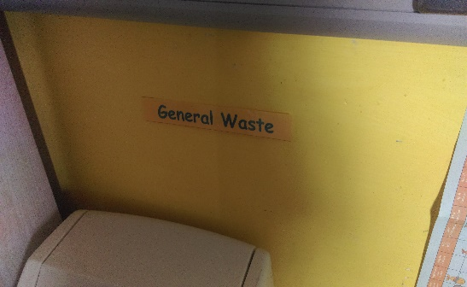 | 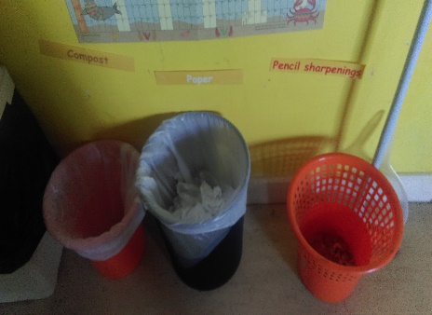 | 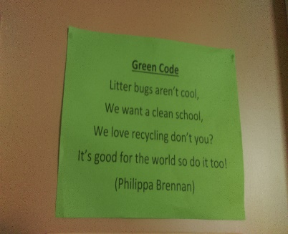
General waste bin | All other bins | Our Green code
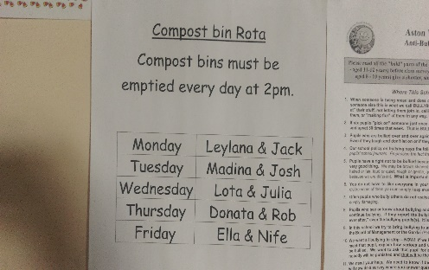 | 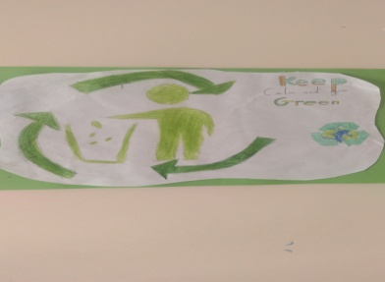 | 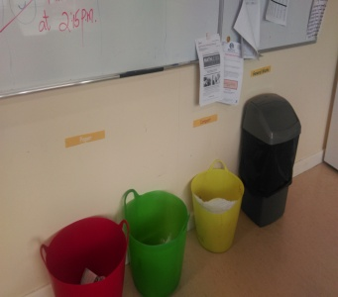
Compost bin rota | Our posters | Staff room bins

Action plan – Energy
As the theme for the second Green Flag is energy we felt we need to look at this area in great detail. We had started using some energy saving ideas, for example, switching off the lights (15 minute rule) use of sensor lights in the school, closing doors etc. We wanted to build upon and develop our energy saving ideas to form a further developed action plan – we highlighted any litter and waste management actions in green and any energy actions in blue. Member s of the student council played the role of the Energy Squad who would patrol the school building to ensure energy saving actions were taking place. Signs were put up around the school to remind everyone to try to save energy.
A copy of the action plan is included in the appendices and is visible on the Green School notice board.

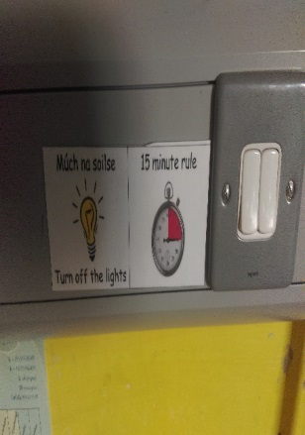 | 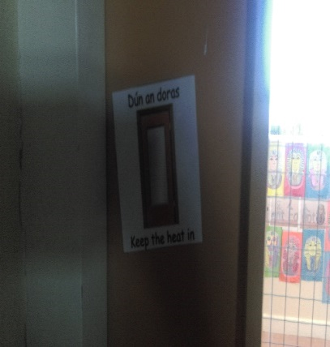 | 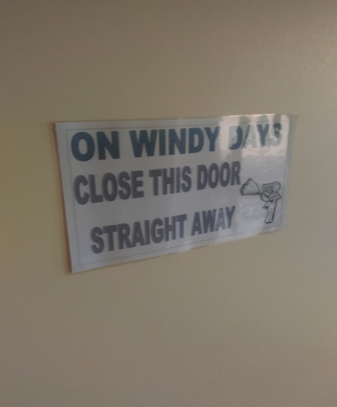
15 minute rule | Keep the heat in! | Save energy
Don’t let the energy vampire suck the life from our school. |  | 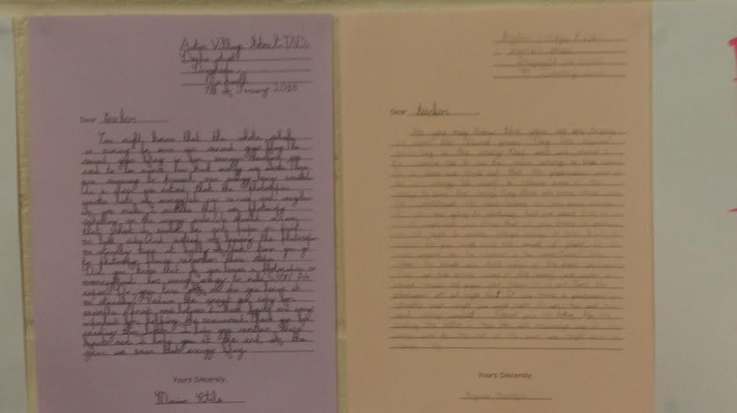
Don’t leave on standby | Check before you copy | Letters from students

Step 4: Monitoring and Evaluation – Litter
Certain targets were achieved when working towards our last flag i.e. Litter picking rota, litter pickers, composters rota, mesh bins, labels for all bins, 4 bins for each classroom. Our system is still as effective as it was in previous years and therefore we continue to maintain it. This year we decided to only add names to the rota if the children were interested, this made sure that the jobs were carried out to a high standard by children who really wanted to be part of a team. The children are vigilant in the quest to keep our school litter free. They patrol the school at break times and we encourage the older pupils to mentor and set an example for younger students.

We have also encouraged children to take an interest in gardening and growing our own vegetable patch, this was very successful with thanks to teacher Brian and caretaker Frank.
Our school garden

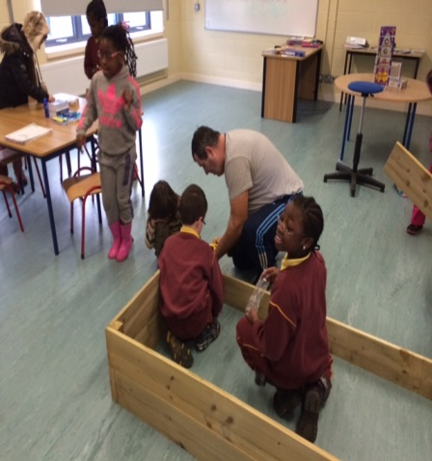 | 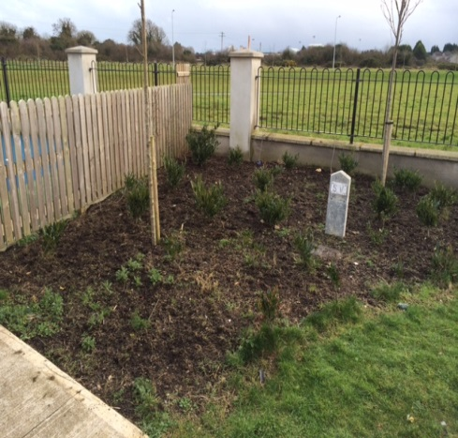 | 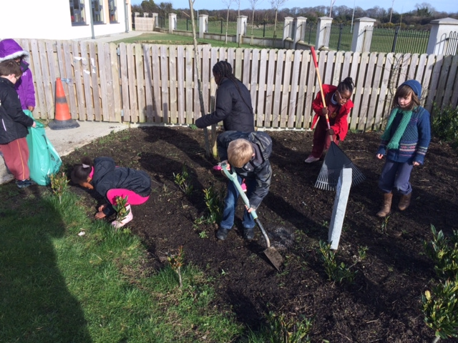
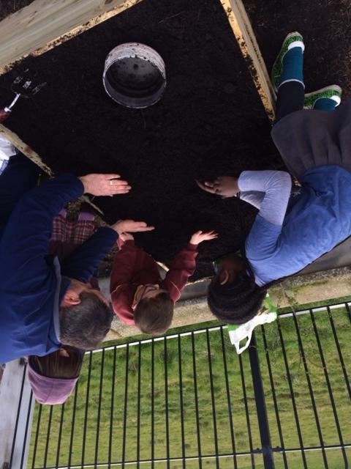 | 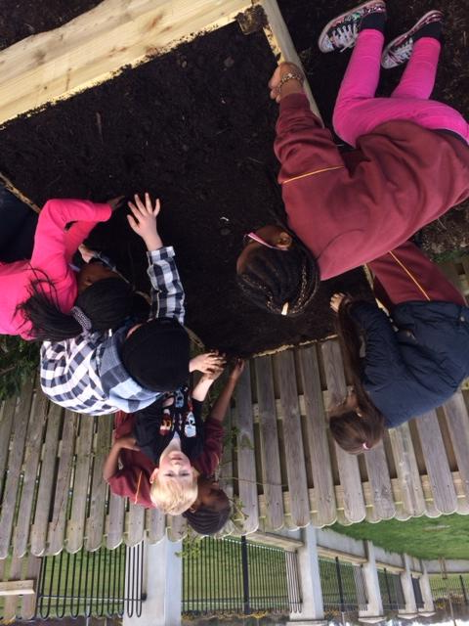 | 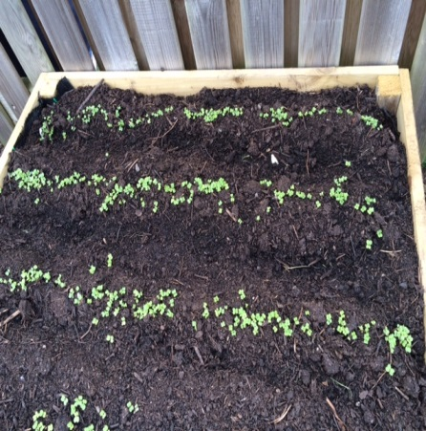

We continued to use waste for our entertainment and the Easter hat parade has become an annual event. The children make their hats at home or at school and parade around the basketball court and winners are selected. It is such a fun day and the children remain very enthusiastic. Therefore we continue to reduce our waste by recycling.
Easter hat parade 2014
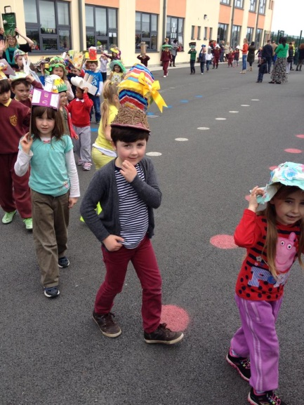 | 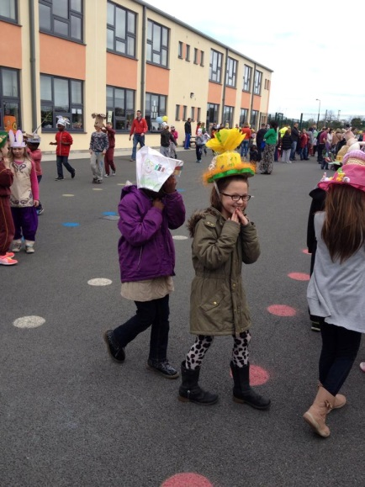 | 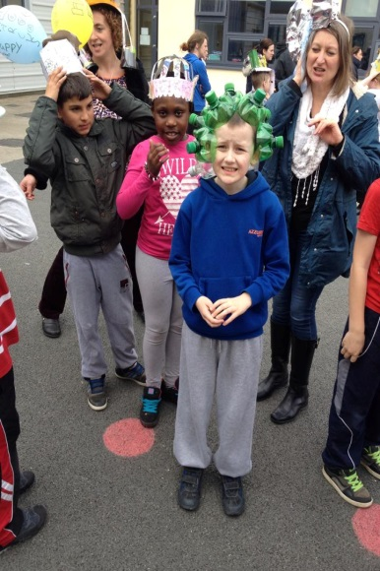
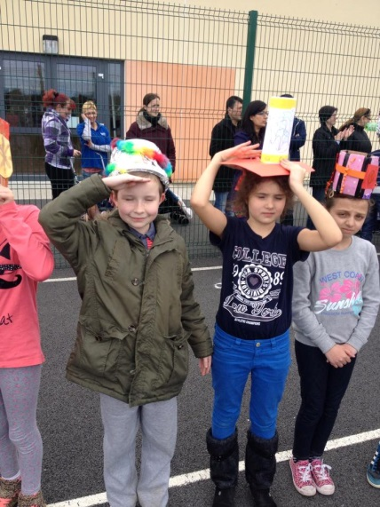 | 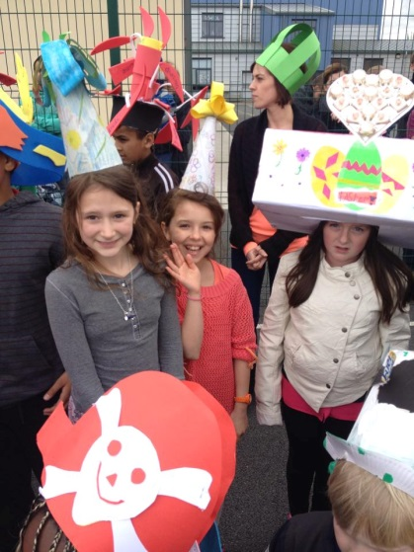 | 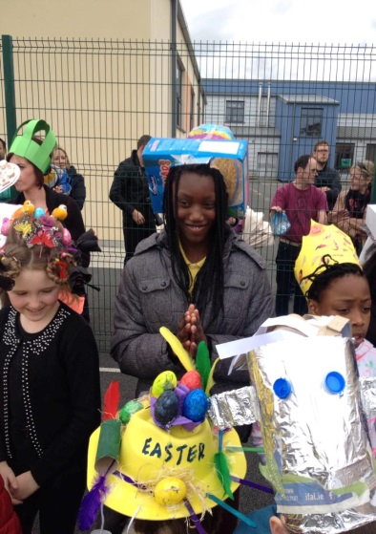

We have also asked all teachers to plan as part of their art lessons – 3D construction using recycled materials. The children in groups create imaginative structures and present them to their class. It is a very exciting activity that the children thoroughly enjoy.

3D construction using recycled materials
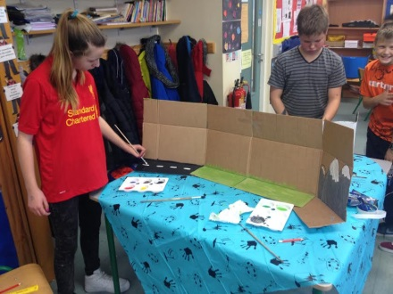 | 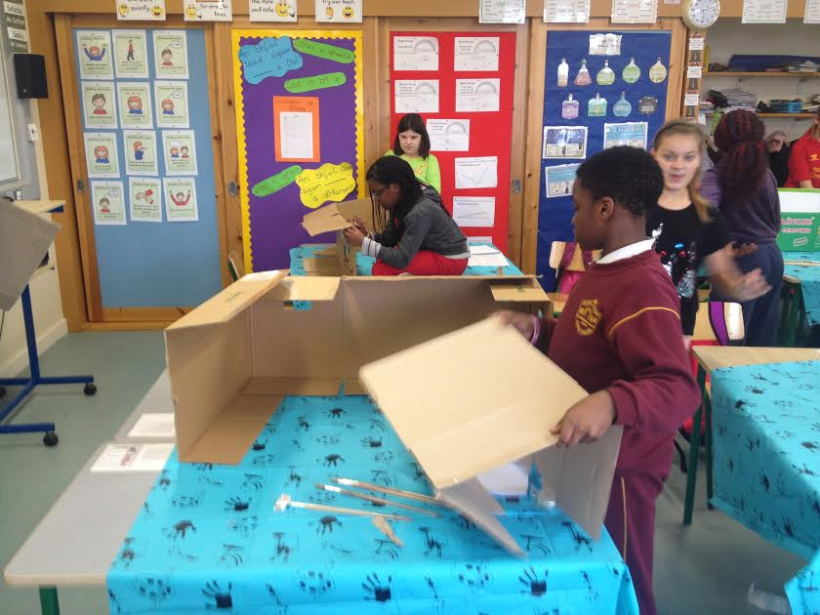 | 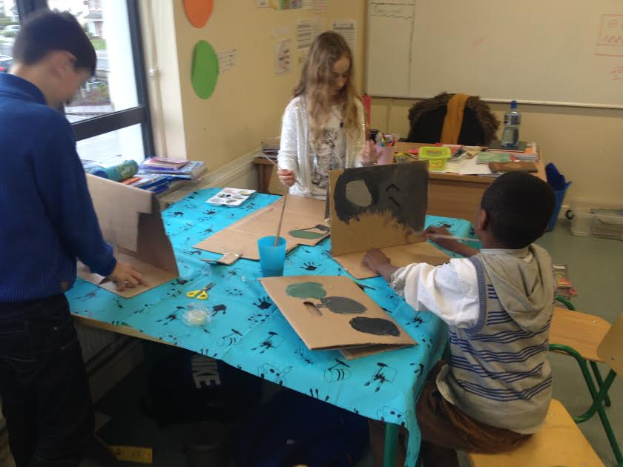
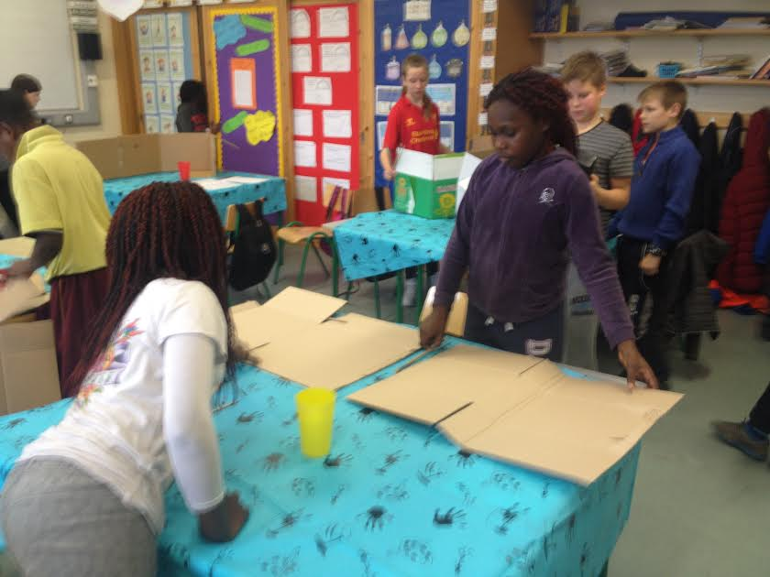 | 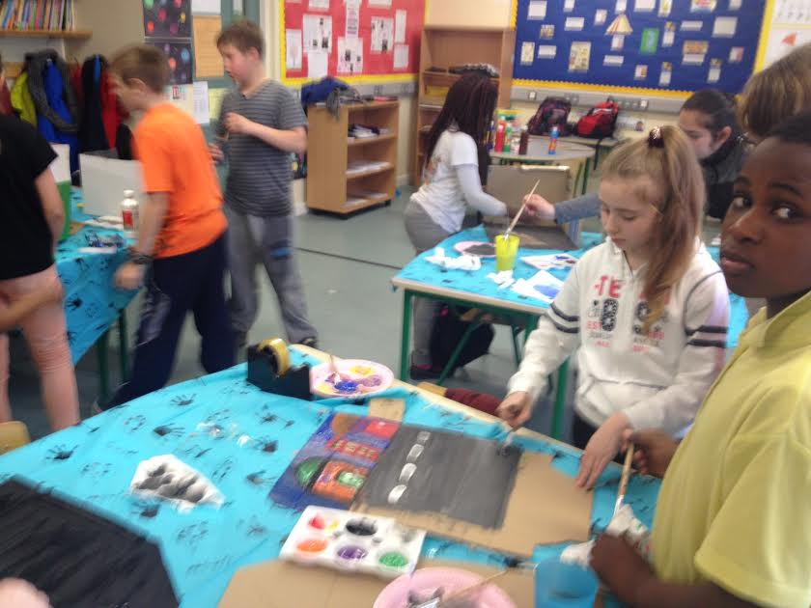 | 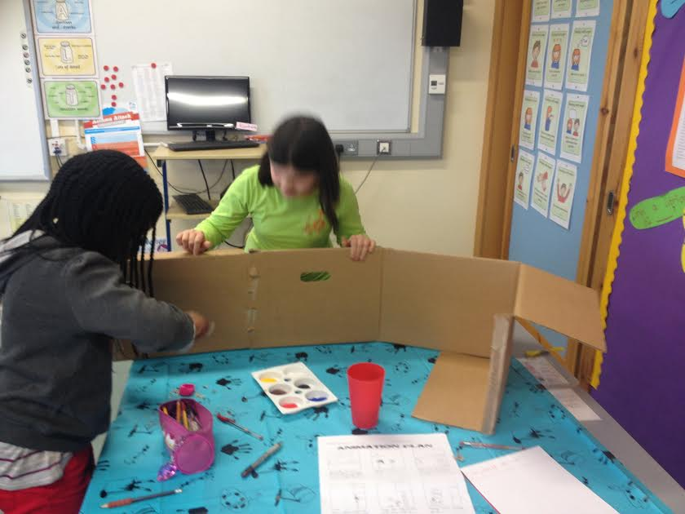

Energy
We have always tried our best to switch off lights when out of the classroom and this was quite successful. This year we have an Energy Squad to monitor energy usage. The squad are made up of children from Junior infants to sixth class and they are responsible for ensuring lights are off, appliances are off and not on standby, doors are closed, blinds are down at the end of the school day, teacher does not have windows open if heat is on etc. We have adopted Energetic Eddie posters all over the school reminding everyone to be energy aware, teacher Liz is creating a life size model of Energetic Eddie using recycled newspaper, 3rd and 4th class have written a song ‘Do you wanna save the planet’ and Adeel in 5th class has written a rap song about Energetic Eddie.
Aston Village are committed to saving energy
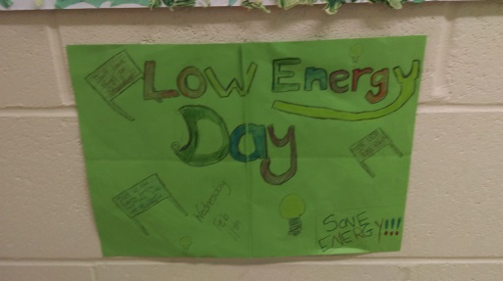 | 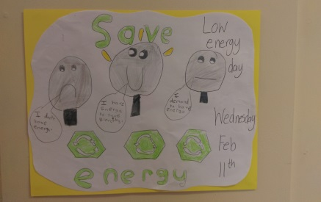 | 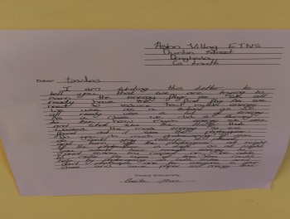
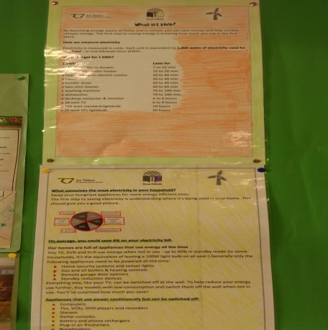 | 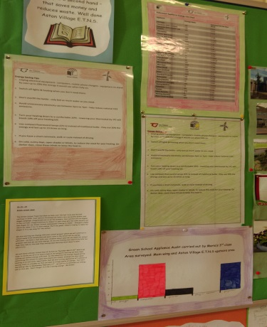 | 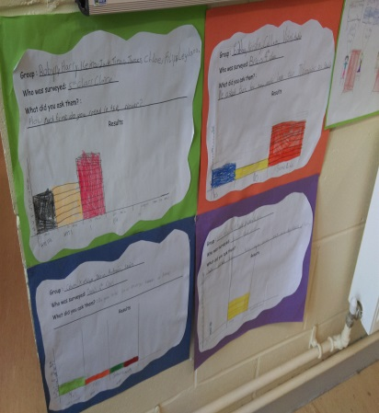
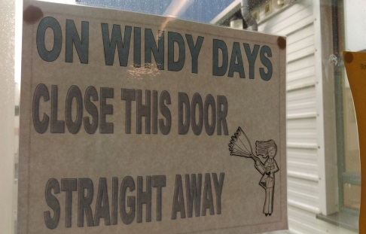 | 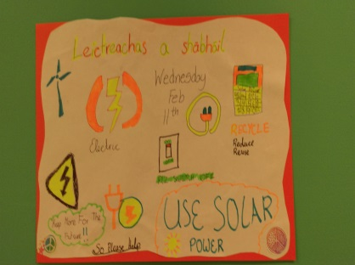 | 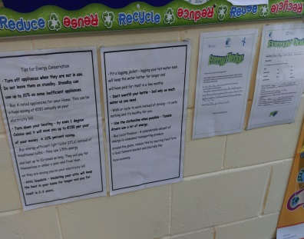

There is no oil central heating in our school, our lights are all sensor operated which saves a lot of energy. We keep track of our kwh usage by contacting Energia our supplier and we have also been in touch with their Educational advisor Cormac Mannion to find out ways we can improve our usage. We are beginning to see a reduction in our usage however it is difficult to monitor this year as we have leased a wing of our school to the new Ballymakenny College Secondary School, though at times our kwh usage has not met our aims it is important for us to remember that there are over 100 extra pupils and a full secondary school staff using our facilities along with a Home Economics room and science laboratory which were not there last year. So we continue to factor this in to our energy review.

Step 5 – Linking with the Curriculum
At present there are over 320 pupils in our school and each one from 4 years old to 12 years old are involved in classroom and whole school work linked to the Green School Programme.

Maths: counting, sorting, estimating, reading meters and temperatures, recording data, analysing graphs, pie-charts and percentages, working out the cost of running appliances, estimating energy savings.

English: oral language, discussions, debates, slogans, posters, letter writing, poems, essays, fact files, newsletters, minutes of meetings and press releases.

Gaeilge: dánta, scéalta ‘ ag obair sa gairdín, an brat glas’, pictiúr, fograí, cluichí.

SESE: seasonal changes and weather, environment, awareness and care, energy, wind, solar, water, renewable energy, non-renewable energy, fossil fuels – gas, oil, coal, green school projects -shoe box school, slogans, posters.

Copmuting – creation of posters, notices, letters, minutes, photos, dedicated green school area on our school website, facebook page, school newsletter, Aston Village Green school news programme.

S.P.H.E: Myself and the wider community, work with Tidy Towns Drogheda, respect for the environment, core ethical curriculum, morals, right and wrong.
Learn Together: Ethics and the environment – fossil fuel pennies, morals, right and wrong, our rights, the rights of the planet, Earth hour.

Art: posters, collage, recycled hat parade, recycled Christmas decorations, 3D models using recycled materials, design an energy mascot – Energetic Eddie, create a life size papier maiche version of Eddie.

Music: Compose and perform energy songs and rap.

Drama: What would you do? , improvisation.

See Curriculum links from a number of teachers attached in our appendices.
Example
Planning – Teacher Liz
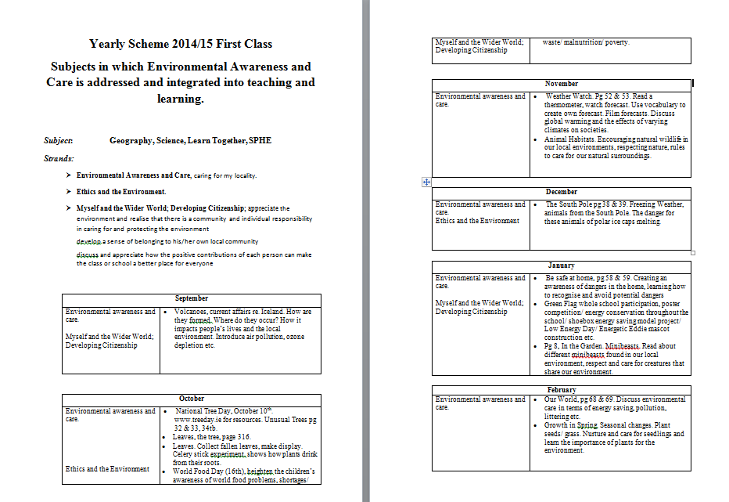
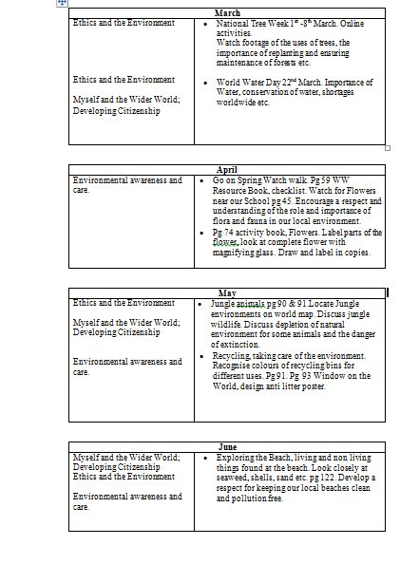
Aston Village is an energy efficient school project
Shoe-box project
As part of our energy awareness campaign each class from Junior infants up to 4th class were asked to design and create a shoebox version of a room in the school. Each room must be energy efficient and represent the best that our school can be.
The staff and children thoroughly enjoyed the project and put so much time and effort in to their shoebox.
The rooms were divided as follows:

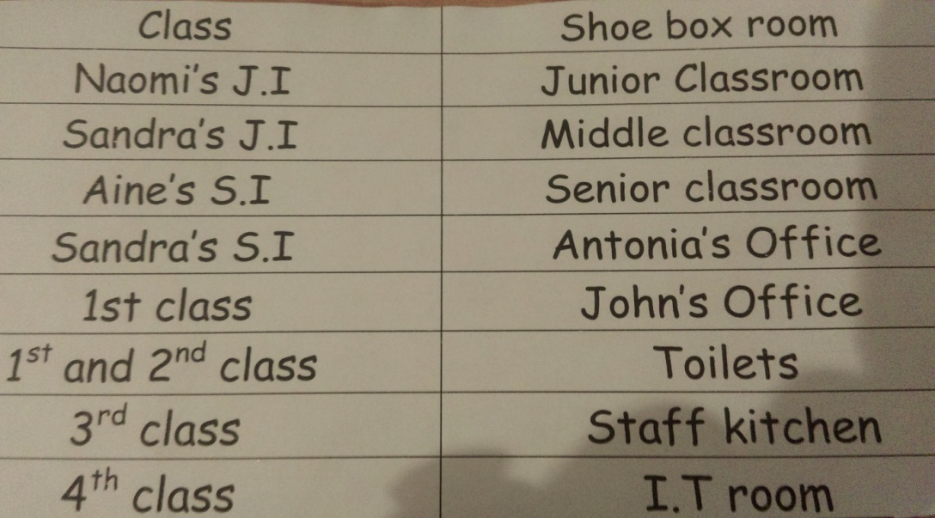

Our environmentally friendly school contains
Electrical appliances
- All electrical appliances have an A rating optimum energy efficiency label
- All electrical appliances are plugged out and never left on standby.
- An energy saving water boiler system is used
Recycling
- There are appropriate bins in each room for general waste and paper and then composting and pencil shavings in the necessary classrooms and plastic in the staffroom.
- The school visits V & W Recycling centre as necessary to dispose of old electrical goods and ink cartridges.
- There is a composting bin in the garden.
- A water butt will be placed in the school grounds.

Lighting
- Compact fluorescent lamps are used throughout the school and all lights are on a sensor system to ensure no energy is wasted.
- The school adopts the 15 minute lighting rule – if you are not going to be in the room for more than 15 minutes - don’t turn on the light. If you are not going to be out of the room for more than 15 minutes - don’t turn off the light !
- Our school will use CFLs as they are more energy efficient than conventional light bulbs which convert only 6% of the power they consume into light. CFL bulbs use only one fifth of the power of a normal bulb to give the same light output and last up to 10 times longer. Assuming an average 8 hours use per day, by switching a single light to CFL the school can save up to €30 per year on replacement bulb and energy costs.

Windows
- Heat loss through single glazed windows can account for around 20% of the total heat loss from un-insulated house. Double glazing can cut this in half. All windows in our model school are double glazed. This also helps reduce noise and condensation problems and eliminates draught.
- All staff members in our school are asked to close blinds when leaving the room – this keeps heat in the school and reduces waste.

Solar panels
- Our school has solar panels on its roof.
- Solar electric panels are made up of silicon, the same thing that makes up sand. The silicon has to be heated to super high temperatures in a big factory and then formed into very thin wafers. When sunlight hits the solar panel, it makes the electrons in the silicon move around. The electrons move through wires that were built into the solar panel and like magic the school has electricity and the water is heated.

Heating
- All staff members in our school are asked to close blinds when leaving the room – this keeps heat in the school and reduces waste.
- The boiler is serviced annually for optimum efficiency.
- A timer is fitted on the heating system.
- The heating is not on when there is no school i.e. midterm breaks, school holidays.
- Radiators are only on in rooms being used.
- Windows are not opened if radiators are on – rads are turned down instead.
- Furniture is not placed in front of radiators
- All radiators have the energy saving silver backing to throw out heat.

Heat retention
- All staff members in our school are asked to close blinds when leaving the room – this keeps heat in the school and reduces waste.
- Doors are closed at all times – patrolled by Energy squad.

Water
- Rainwater is collected in a water butt which is used to water school plants.
- There is an underground water storage system used for toilets.

Our energy efficient school in pictures
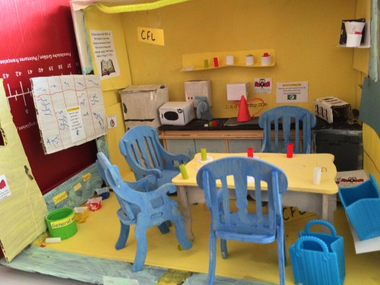 | 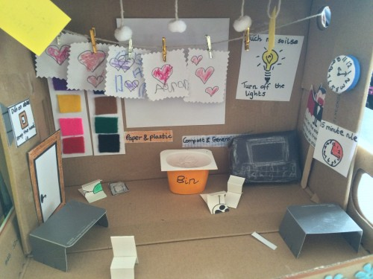 | 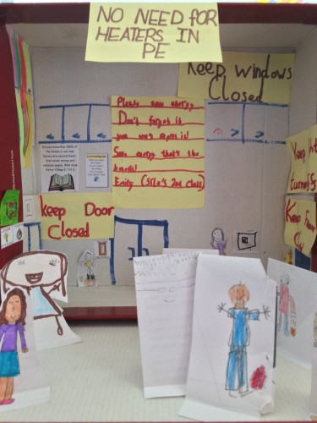
Staffroom | Junior classroom | P.E hall
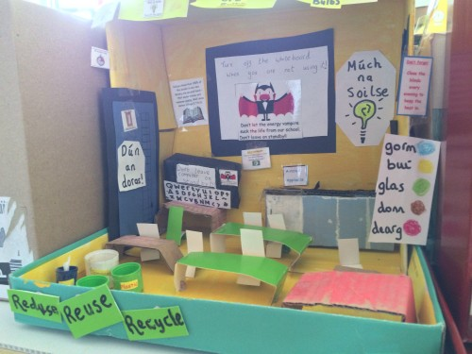 | 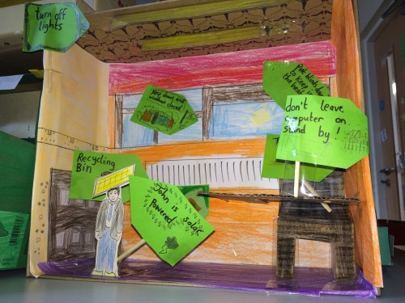 | 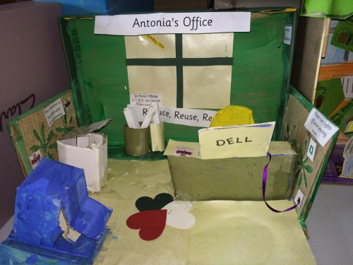
Senior classroom | John’s office | Antonia’s office
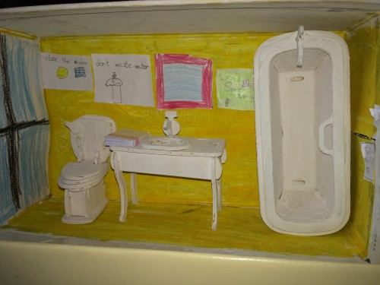 | 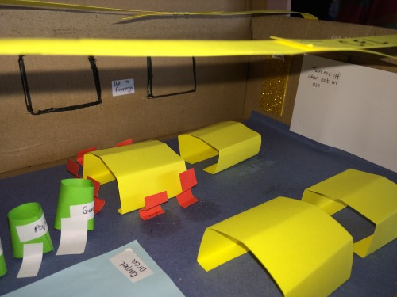 | 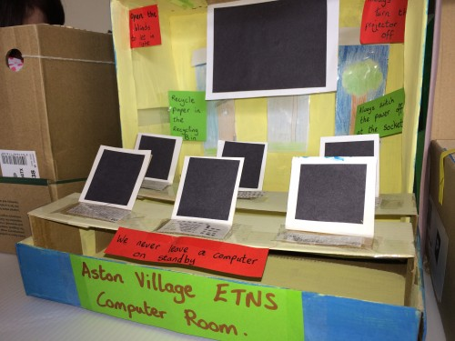
Toilets and shower room | Middle classroom | Computer room
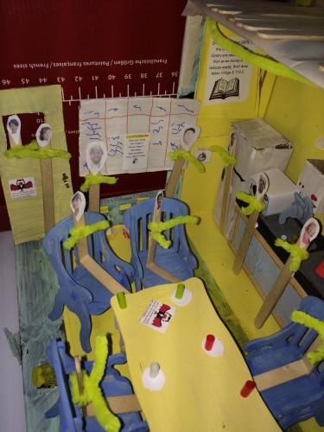 | 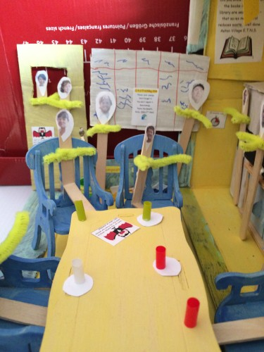 | 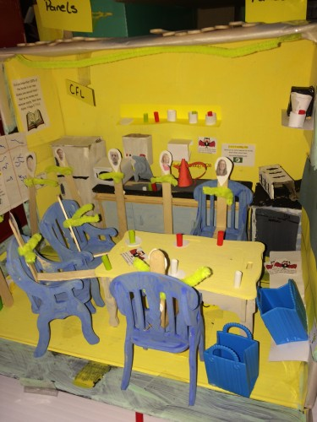
Our | Green | staffroom

Step 6: Informing and involving
- Each class was involved in our road towards this Green flag in different ways.
- The Green Team and Maria devised the Action Plan and kept all staff and pupils informed and received ideas from staff and pupils.
- Our Green School notice boards inform all pupils, staff, parents and visits of the busy work of the Green School Programme.
- Our poster campaign was very successful and continues to inform and remind the school community.
- Our energy saving slogan, our mascot Energetic Eddie ad our Energy saving green code involved all of the school community and parents.
- Curricular work – all pupils and staff involved.
- Energy saving newsletter produced and circulated to all pupils and households.
- Earth hour notices sent to all houses on recycled paper.
- Green School TV – available on our school website and Facebook page.
- Green school area on our website – this informs our school community and the wider community, this can also cut down on our use of paper.
- Our link with Drogheda Tidy Towns – allows children to show their environmental awareness.
- Students will visit V&W Recycling centre in Term 2 of the school year 2014-2015.
- Coverage of our Ethics and the Environment lesson on Newstalk national radio.
- Advertisement of our An Taisce Spring Clean on LMFM local radio.
- Local newspapers The Drogheda Independent and Drogheda Leader will be invited to our Day of Action 2015.

Day of Action
Every day could be described as a day of action regarding the environment at Aston Village E.T.N.S. Our daily litter wardens, composters and energy squad patrols ensure an energy efficient and green school.

Energy saving day – Low energy days 2014 & 2015
We conducted a low energy day in May 2014 where all teachers and students were asked to keep their energy usage to a low. Classroom lights remained off, heating was off, photocopier was not used, laminator was not used, computers, projectors, tape recorders, cd players were not used. Cleaners did not use hoovers and the washing machine and dishwasher were not used. It really was a low energy day though the teachers and children used lots of their own energy.
In 2015 we decided to try to have a low energy day in Term 2 & we will have another low energy day in Term 3.

Low energy day 2014 & 2015
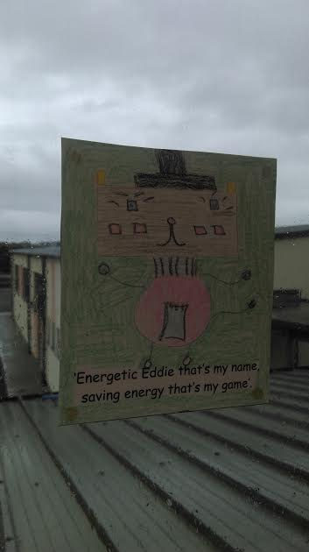 | 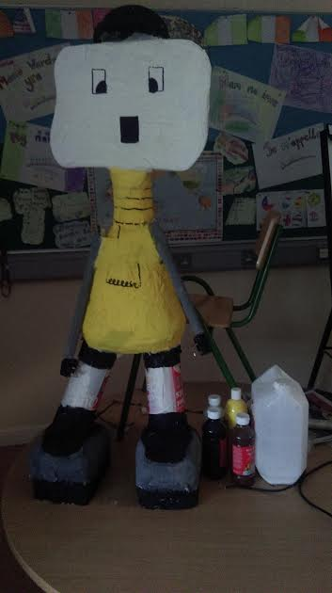 | 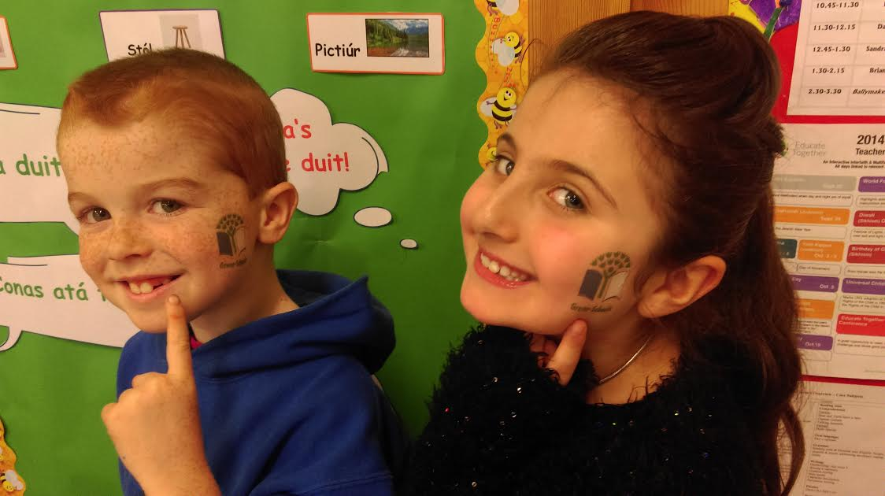
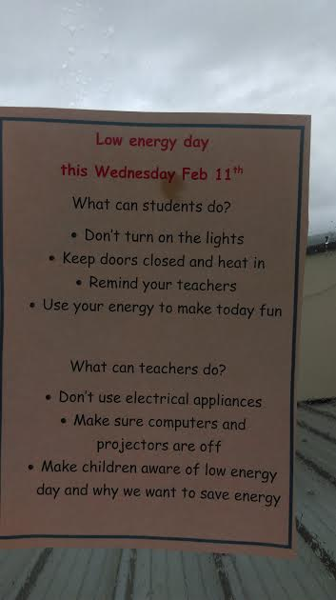 | 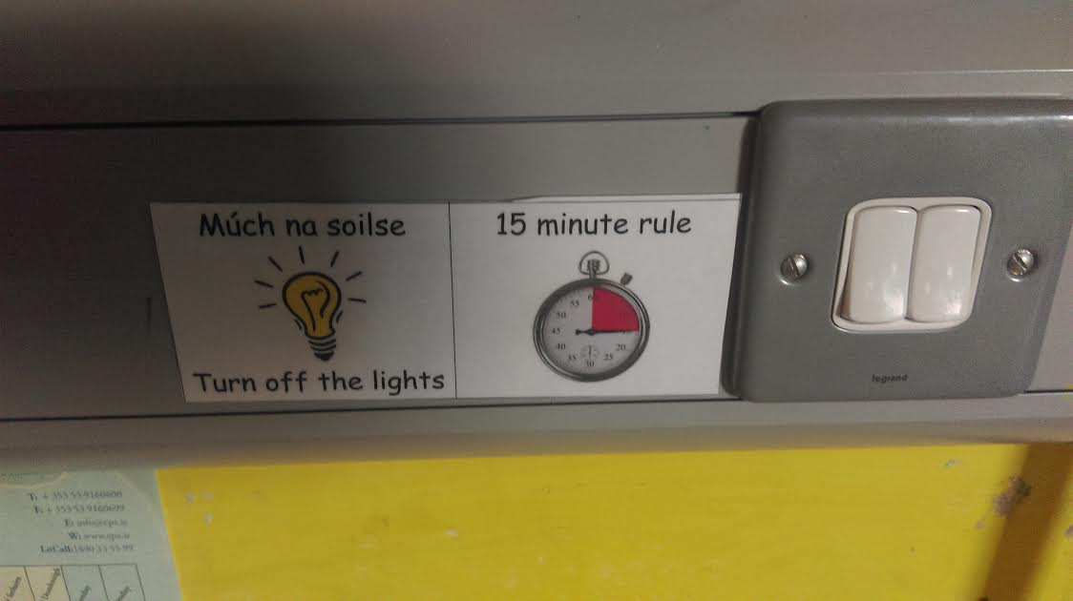 | 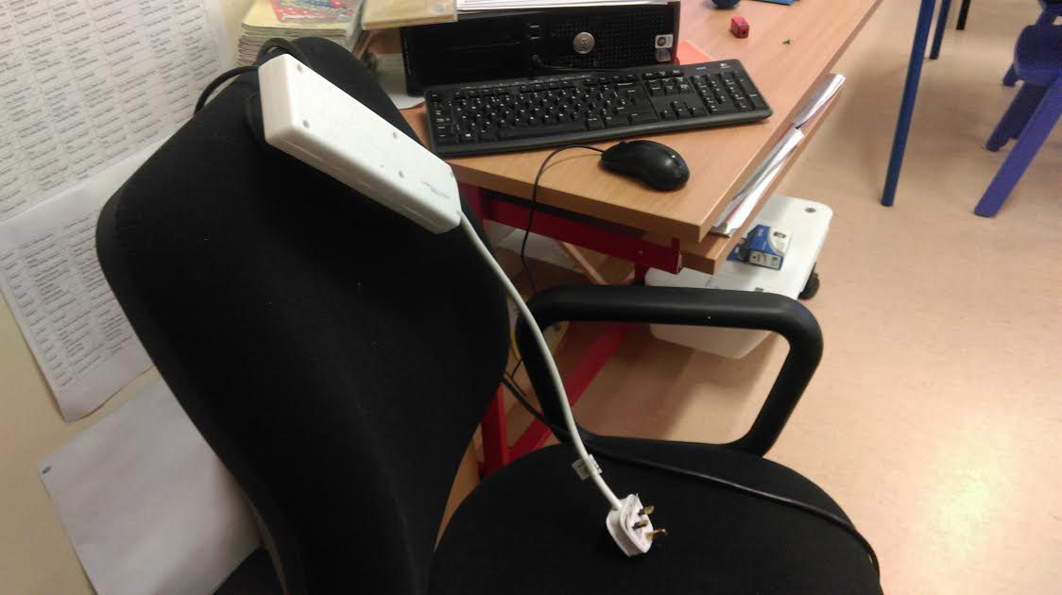

An Taisce National Spring Clean
Aston Village E.T.N.S registered for the National Spring Clean this year and we are very excited as it is our first time to register. We will Spring clean our school grounds and the surrounding green areas of Aston Village estate and Termon Abbey, we hope to get members of the estate together to make it a big success.

Environmental action
Last year teacher Brian and Frank led an afterschool club to promote gardening and self-sufficiency. The club was a huge success. Brian comes from a family of horticulturists and was very knowledgeable in the area. The children cleared an unused area of the school and Frank made beds for planting. The children planted potatoes and carrots and lots of other vegetables. It was a very enjoyable experience and the best part was that before Summer holidays the children got to dig up the crops and sell them to parents in the school yard therefore making a profit for themselves and the club.
This year we will involve all classes in order to increase environmental action and awareness. Each class grouping will be assisted by Brian to prepare the beds and plant the crops, the will all reap the rewards come summer and they will get to enjoy the fruits of their labour.
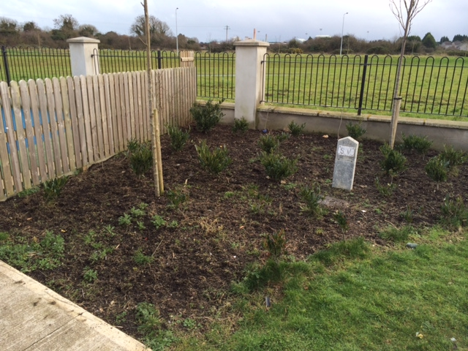 | 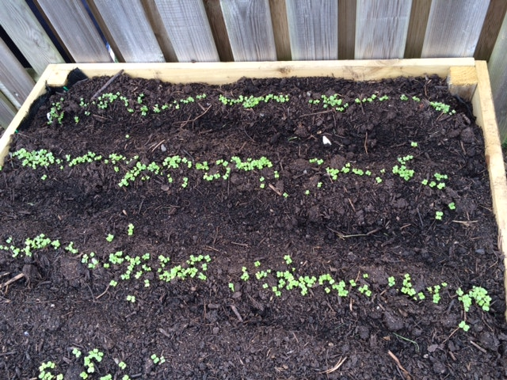
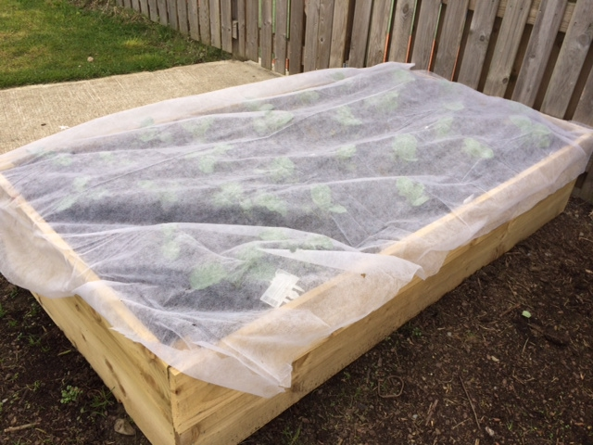

Contacts with the wider community
In cooperation with Tidy Towns we are trying to increase our involvement with our local community. We are delighted to have made a link with Eddie and Áine from Drogheda Tidy Towns and we look forward to working with them in the future.
This year we plan to co-operate in the following ways:
- An Taisce National Spring Clean
- We will you the An Taisce Spring Clean to clean up our area and next year when we are more established we hope to make it in to a bigger event – maybe even a huge week long estate clean up.
- Children will ensure that all areas around the school entrance and the green beside the school are kept clean.
- Continue to be a lunch box school which decreases waste and the chances of waste leaving the school area and contaminating the estates.
- We would also like to take part in the Louth County Council poetry competition.
- We would like to progress to the Platinum award for the Louth Primary School awards and show our dedication to keeping our school and our community green.

Step 7: Green Code
All the pupils love the slogan competition as it gives them a sense of involvement and they love to see the winner slogan around the school.
Our first green code was
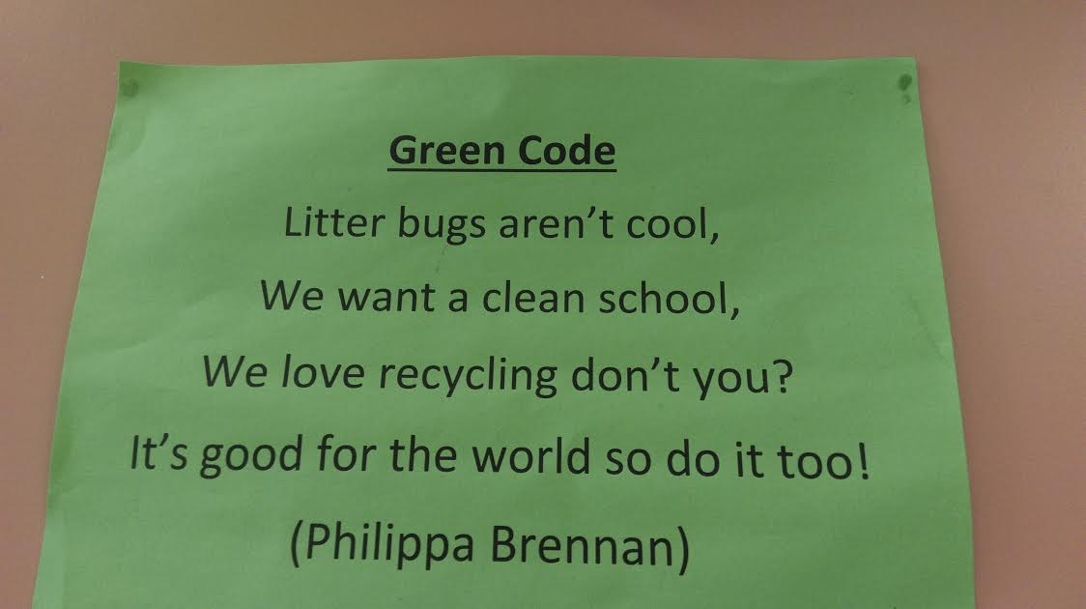

This was written by Philippa when she was in 3rd class, Philippa is now in 5th class and loves to see that her code is still visible in the school.

This year we have selected
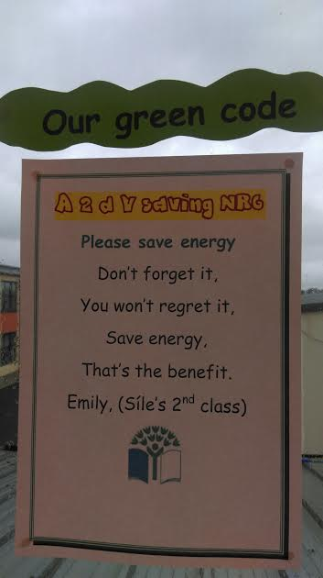

as our energy code. Congratulations to Emily in Síle’s class for coming up with the winner.

Our tag slogan
Has also become very popular, along with our mascot’s saying
‘Energetic Eddie that’s my name, saving energy that’s my game’.

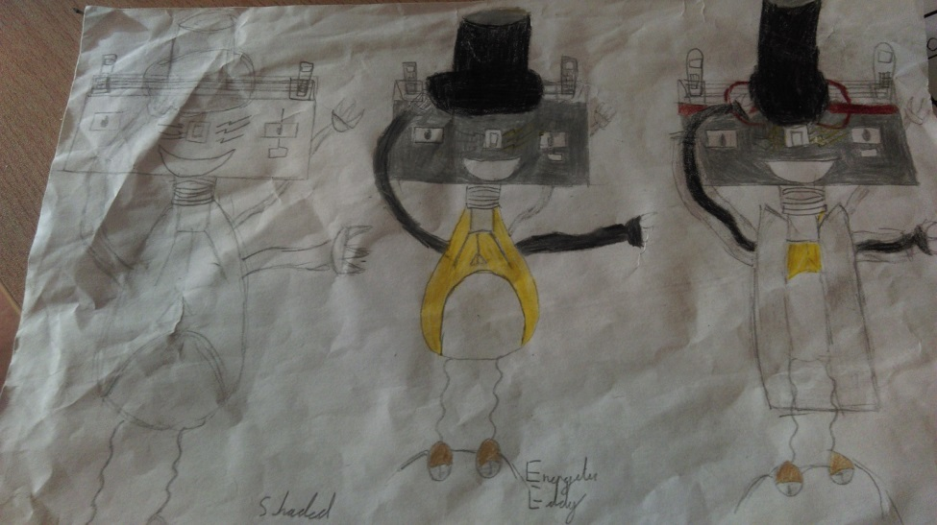

Eddie even became a larger than life mascot, thanks to Liz and the Green team.

Green schools benefit to our school
So how has the experience of Green schools benefitted Aston Village E.T.N.S?
There was much excitement and enthusiasm when we were awarded our first Green Flag that there was no difficulty whatsoever in getting pupils and indeed involvement from the school and wider community. Children were very eager to be litter pickers, energy squad members and part of the green team; the school involvement highlights the success of the programme. There is a huge sense of pride in the school among teachers, students and parents. Following the success of the first flag, it was easier to see the benefits and the linkage through the 7 steps and this made us more focused and everyone contributed whatever way they could.
We have really enjoyed our journey through the 7 step process towards achieving our second flag and we look forward to flying it with pride in our school grounds soon.

Preparation and talks have already started in our work towards our next theme which is water. We are hoping to invest in a water butt and many more water saving ideas are starting to flourish.

Our 7 steps towards our green flag renewal
Step 1:
Re-election of Green school committee. Continuity of the committee was ensured as there was a thorough hand over from one committee to the next each year.

Step 2:
We drew up and answered our Environmental review. Most litter and waste objectives had already been achieved and best practice needed to continue. Some energy saving methods had started and we expanded upon these.

Step 3:
We drew up our new Action Plan. We have managed to implement most of our actions but some will continue until achieved before June.

Step 4:
We formed our new litter patrol systems and our energy squad teams. Each group was advised of their job descriptions. They monitored litter, waste and energy saving in our school. We made note of our kwh usage and made a conscious effort to reduce energy use. We held an energy saving day in May 2014, February 2015 and we hope to have another in April 2015. This really reduced the energy used in our school and increased the awareness levels of the children.

Step 5:
We linked our Green school project with our curriculum work in all subject areas and we displayed all our work in the green school area. We took photos of all our activities and they are displayed in the Green school area beside the office.

Step 6:
We included a notice from the Green school team in many of our school newsletters in the 2013-214 and 2014-2015 school years. We have a Green Team area on our school website www.astonvillageetns.com and we made all our Facebook followers aware of how Green we were. We also made episodes of Aston Village Green Team news which is available on our website and Facebook page.
We kept parents informed about our low energy days, day of action and also Earth hour.
We will take part in the An Taisce National Spring Clean this year.
We made a link with Drogheda Tidy Towns and our electricity supplier Energia.
We also moved all our payment systems to digital systems to reduce paper and waste.
We are in the process of making our own Green Team interactive game to promote Energy awareness and safety.

Step 7:
We ran a school competition to find a new Energy mascot and Energy Green Code. The winning entry is

Appendices
1. Environmental review
2. Completed analysis and samples
3. Action plan
4. Press information
5. Newsletter samples
6. Letter writing
7. Energy efficient school – shoebox project
8. Environmental Awards – Louth Primary school awards
9. Sample minutes from Green school committee meetings
10. Sample school signs
11. Green School song
12. Green school rap
13. Electricity usage
14. Energy mascot - Energetic Eddie
15. Energy code
16. Correspondence with Tidy Towns Drogheda
17. Correspondence with Energia Electricity Company
18. Curriculum Links
19. Composting, energy squad and litter picker rota
20. Day of Action and projects

